Changes to Blackboard
In December 2021 USW moves to a SAAS (software as a service) version of Blackboard Learn. This version is almost identical to the version we use now and USW staff should not encounter any disruption as this change is made. However, when creating new content staff will notice a difference in the Text editor. This text editor appears wherever you can add and format text, such as in course content items, assignments, tests, discussions, blogs and journals.
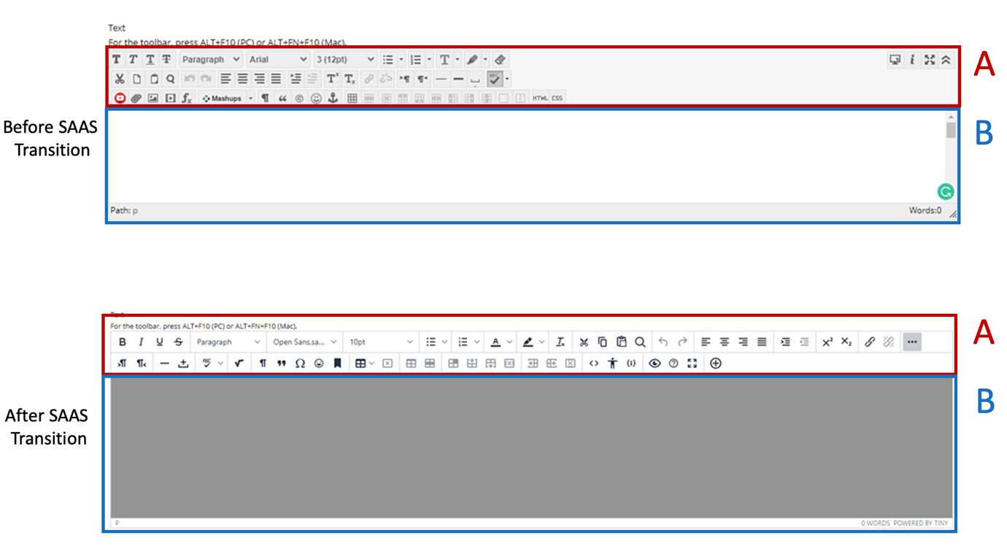

Diagram showing the new editor and its functions

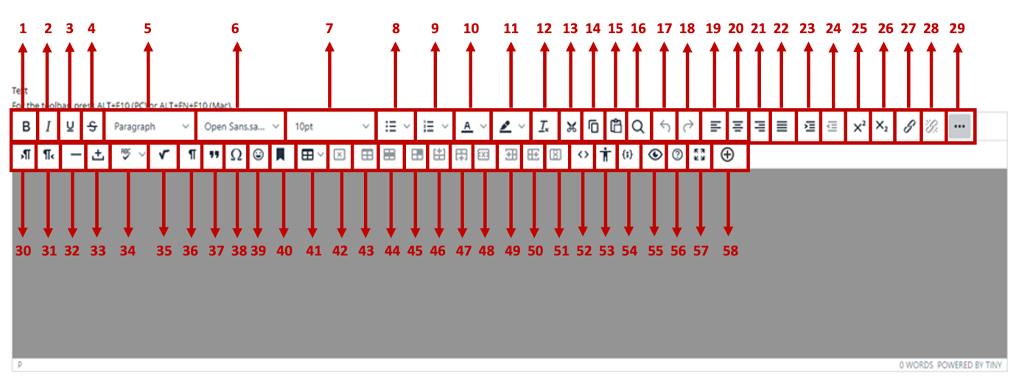

Function Number | Operational Property
 | Bold Text
 | Italic
 | Underline
 | Strike-through
 | Heading
 | Font Type
 | Font Size
 | Bullet Point Function
 | Paragraph Numbering Function
 | Text Colour
 | Highlighting Colour
 | Clear Formatting
 | Cut
 | Copy
 | Paste
 | Find
 | Undo
 | Redo
 | Align Object Left
 | Align Object Centre
 | Align Object Right
 | Align Full – Justified Edges
 | Indent Left
 | Indent Right
 | Super Script
 | Sub Script
 | Insert and Edit Hyperlink
 | Remove Hyperlink
 | Expand/Collapse Extra Buttons
 | Text Direction Left to Right
 | Text Direction Right to Left
 | Horizontal Line
 | Nonbreaking Space
 | Spellcheck…
 | Insert a Math Equation
 | Show Invisible Characters
 | Blockquote
 | Special Character
 | Insert Emoticon
 | Anchor
 | Insert Table
 | Delete Table
 | Table Properties
 | Row Properties
 | Cell Properties
 | Insert Row Before
 | Insert Row After
 | Delete Row
 | Insert Column Before
 | Insert Column After
 | Delete Column
 | Source Code
 | Accessibility Checker
 | Insert/Edit Code Sample
 | Preview
 | Help
 | Full Screen
 | Add Content

