Linking Blackboard and Panopto

Provisioning and adding a ‘lecture recordings’ menu item in Blackboard
Before recording with the Panopto application you must first prepare your Blackboard module area for use with Panopto. Panopto needs to be activated – or provisioned - for each Blackboard module that you want to record to. Please note, you must have the Leader role on Blackboard module you wish to provision.
To provision your module and allow students to view recordings, you should add a link from the course’s Course Menu to the list of recordings. This will automatically display an indexed view of all recorded Panopto sessions contained within specified Panopto folders. Once set-up and configured Panopto recordings will be made available automatically depending on availability criteria selected.
This process only needs to be completed ONCE for each Blackboard module.

Steps
- Log on to Blackboard and access the module.
- Make sure Edit Mode is ON.
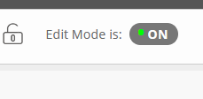
- Click the + button at the top left of the Course Menu and select Tool Link from the menu.
- Select Panopto Course Tool Application from the drop-down menu and then type ‘Lecture Recordings’ or similar as the Name field. Importantly, please tick the Available to users checkbox if you want to make the Panopto link available to students. Click Submit.
- Click on the Lecture Recordings menu link (created in Step 4). Click on Configure.
- On the Configure Panopto Course page that opens select the Add Course to Panopto button
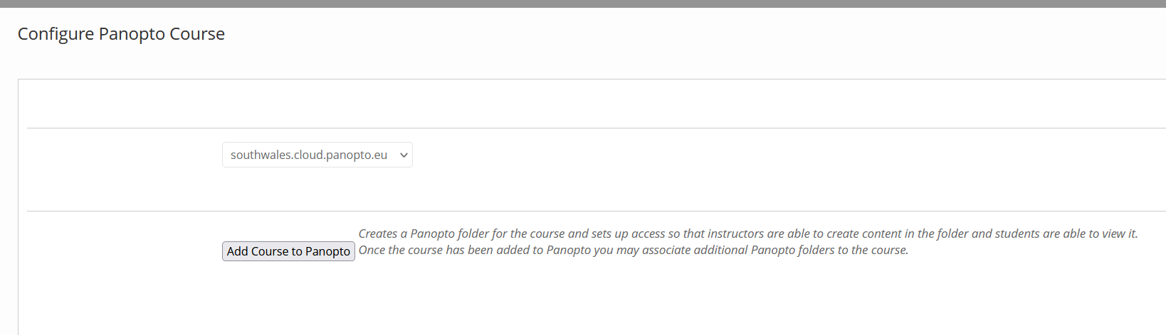
- When the Configure Panopto Connector process is completed you will see the Provision Results page. The last line should read: Successfully provisioned course ID and Name of your course. Select the Return to course button to finish the provisioning process.
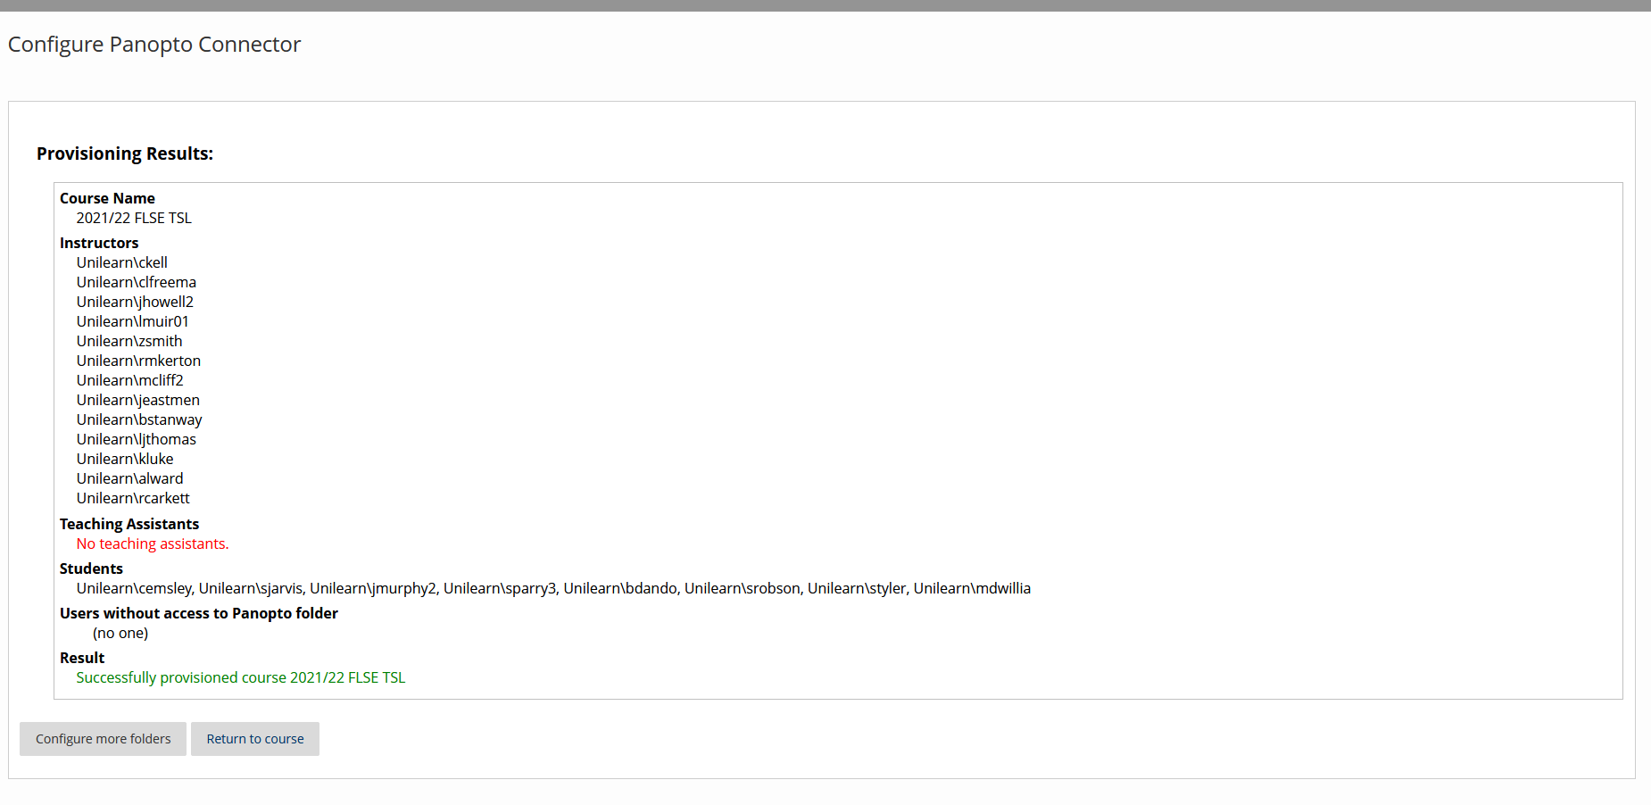

Note: This process only needs to be completed ONCE for a Blackboard module. Leaders of the provisioned module will now be able to record directly into the associated Panopto folder and enrolled students will be able to view recordings in Blackboard via the menu item.

Embedding recording into learning content

Alternatively, you may like to add individual links to recordings within Blackboard content areas and folders. You may like to use this method if you wish to associate a session with additional items, materials and activities. For example, you may like to include key literature around a specific session recording, add a follow-on quiz or use the session recording as a link into online active activities, such as using a discussion forum. Using the individual video link option also allows leaders to assign Adaptive Release criteria to items. Guide: How to Embed a Video into a Blackboard Course from the Build Content menu.

